AMB 200
Legacy Community Connect
Epic Hyperdrive 2026

WHA Perinatal RN Training Guide

Contents

Module 1: Signing in to Epic 3
Exercise 1: Open the Citrix Receiver 3
Exercise 2: Log into Hyperspace 4
Module 2: Basic Navigation and Functionality of Epic 5
Exercise 1: Hyperspace Toolbar 6
Exercise 2: Navigate to the other Workspace Tabs 8
Exercise 3: Multiple Provider Schedule 9
Module 3: Clinical Workflows 15
Exercise 1: Chart Review – Getting up to speed on your patient 15
Module 4: Obstetrical Workflows 20
Exercise 1: MFM Consult, Initial Prenatal 20
Exercise 2: Return Prenatal Visit w/NST Documentation 34
Exercise 3: Pre-Charting 44
Exercise 4: MOD Risk Return Prenatal Visit 46
Exercise 5: 3 Week Postpartum Telehealth Visit 49
Module 5: Other Clinical Workflows 57
Exercise 1: Nurse Visit for Insulin Teaching 57
Exercise 2: Nurse Visit & Clinic Administered Medication Documentation 60
Module 6: IN BASKET Workflows 68
Exercise 1: Access the In Basket Activity 68
Exercise 2: In Basket Functionality Demo 69
Exercise 4: Create Staff Message 75

Module 1: Signing in to Epic

Exercise 1: Open the Citrix Receiver

Objective: To show learners how to access and log into the Epic system.

We will now log into the system and get started for the day.
In the clinic, you will click on the Legacy Apps icon on the desktop:

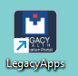 - This is the default access to the system.

- Double-click the Legacy Apps icon.
- Then click Hyperspace ACE 1.

*Notice the moon icon  at the bottom right side of the login screen, if clicked it will change the background of the Epic login screen.

Exercise 2: Log into Hyperspace

Objective: To show learners how to understand and locate information specific for training class.
Direct each learner to their Tent Card. Point out the User ID, Password, Departments, Patients and Providers.

Have new hires/students Login with their Tent Card information:
- User ID: WHAMA##
- Password: train
- Login Department: WHA Northwest Perinatal
- Message tip of the day; Click Ok

Module 2: Basic Navigation and Functionality of Epic

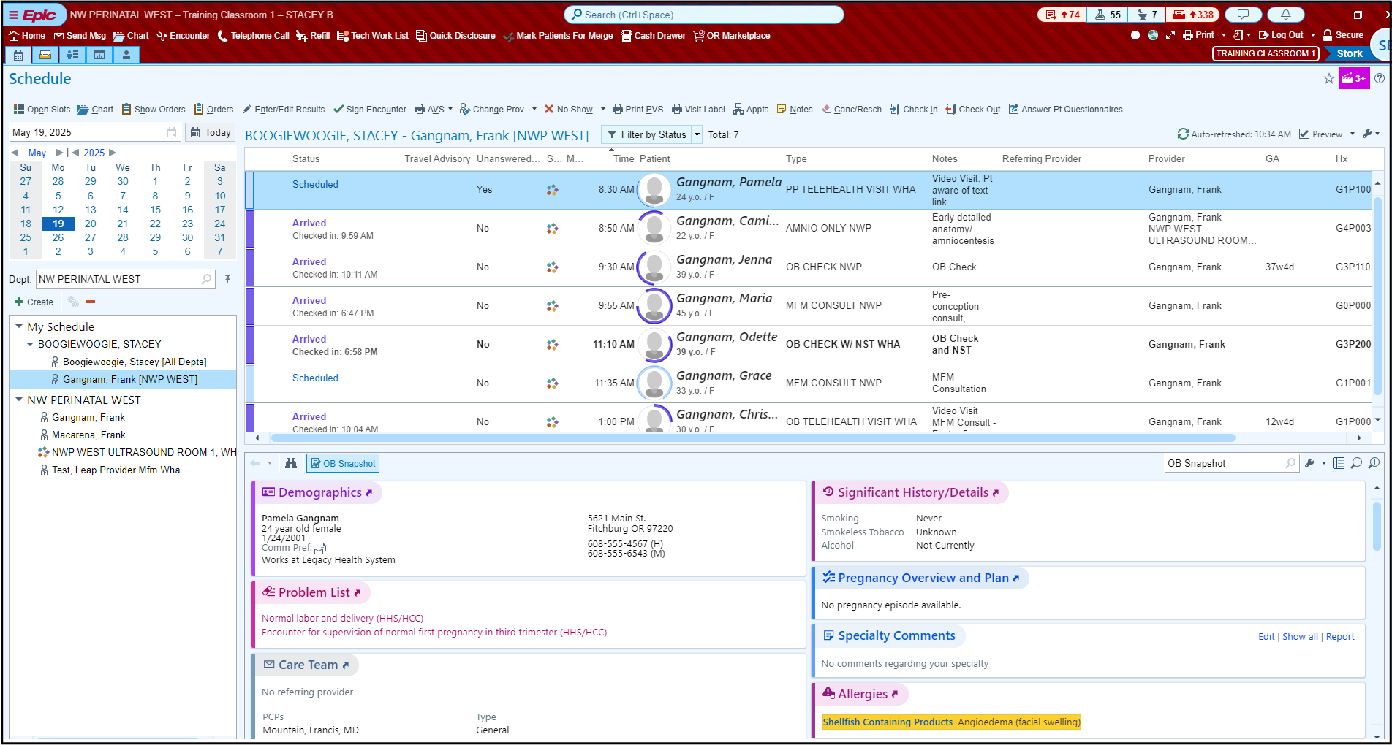

Exercise 1: Hyperspace Toolbar
Objective: Learner is comfortable with navigation and accessing specific activities.
These are common activities for your job role, available for quick access.
Epic button: Located on far left of the hyperspace toolbar. It contains your favorites, recent activities and less frequently used features. This is a lot like your All Programs button on your computer at home minus solitaire.
Home button: Takes you to your default home screen
Send Msg button: Begins the process to create a staff message.
Encounter buttons. Opens the Patient Lookup window to begin the process of starting an encounter
We will explore the other activities throughout the class, and others on this menu you may never use in your job role.
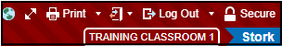

To remove and add activities to our Hyperspace bar:
- In the hyperspace tool, right click on my smartphrase and select remove.

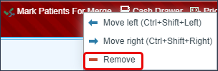
- Rearrange the icons by clicking on a tab and drag and drop to your preferred order.

Log Out/Secure 
Log Out button: Logs you completely out of Epic. Use for breaks, lunch or leaving for the day.
Secure button: Looks like a padlock. It prevents unauthorized access to the record (e.g. patients in unattended exam room). Also bookmarks the screen to open when signing back in. Secure is used whenever you leave the exam room, or whenever you leave your workstation.
Notification Center
InBasket icon: Takes you to InBasket tasks.
Secure Chat icon: Communication with providers for urgent needs.
Notification Center icons: Access to InBasket work, secure chat, and arrival of patients.

My Settings 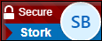
You can customize Epic to your personal preference from notifications to accessibility. You can also log out/ secure through this feature.
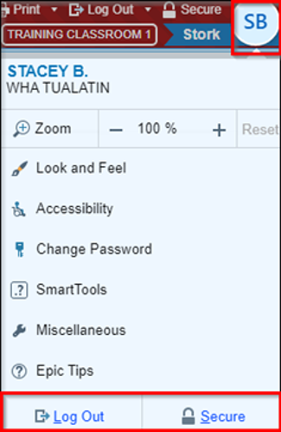

Exercise 2: Navigate to the other Workspace Tabs
Objective: Discuss how to navigate around Epic and what different activities are available for different workflows.
‘Hover’ over the workspace tabs to discover the tabs activity.
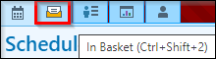
- Schedule tab: This displays daily appointment schedules for individual providers or for the entire department.
- In Basket tab: This represents the In Basket activity, which is the communication hub for clinician tasks.
- Legacy/My Dashboard tab: Click to find resources available under MyLegacy Intranet Links.

- Click the Schedule button.

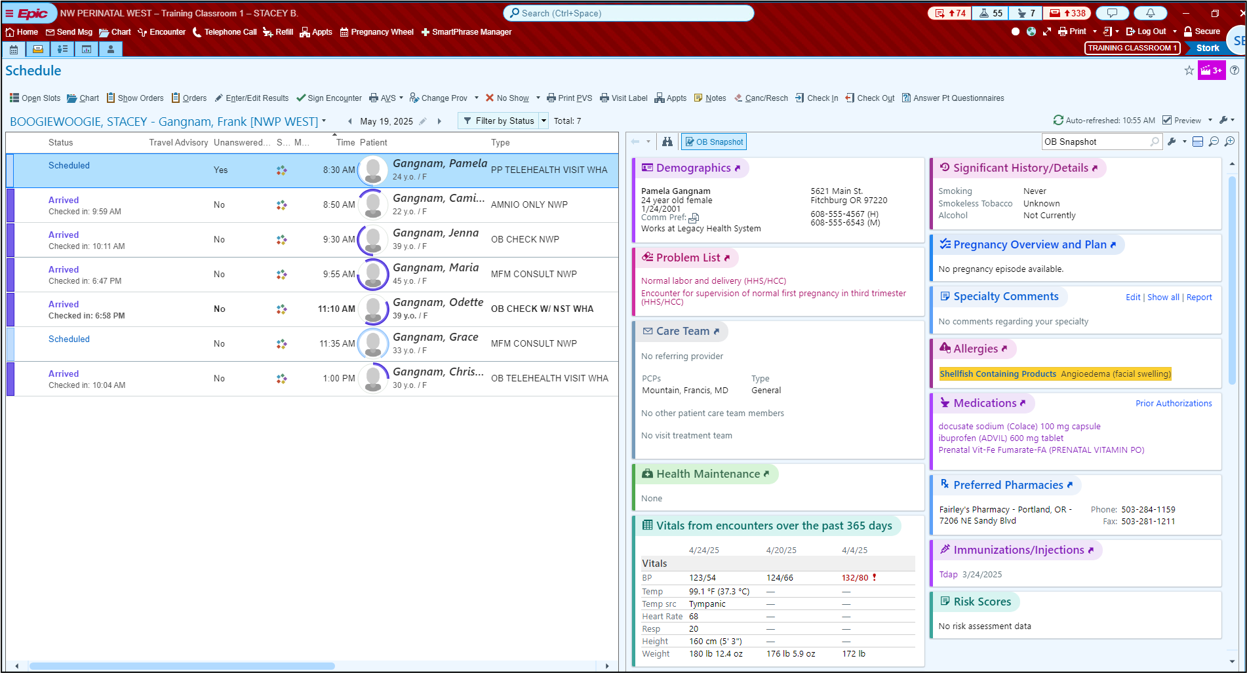

Exercise 3: Multiple Provider Schedule
Objective: Learner understands basic navigation and accessing specific activities.
Now we will explore the Provider Schedule window.
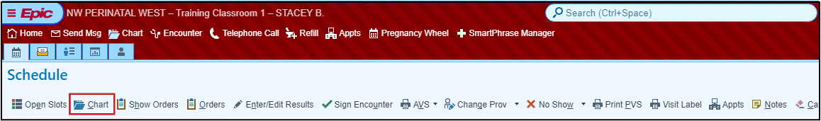
Activity buttons: specific to the activity or window currently viewing.
(Chart on main toolbar vs Chart in the Schedule activity.)
- Chart on Main toolbar opens the Patient Lookup window.
    - 3, 3 Rule - type the first three letters of the patient’s last name, and then first three letters of first name.
      - Example: Wes, Katherine for Katherine West
    - First three letters of first name (space) first three letters of last name.
      - Example: Katherine West
    - Phone Number: Type ph. (space) and phone number to locate patients from your caller id: (Example: ph. 971-555-1234)
- Chart above calendar on Schedule activity opens Chart Review for the patient you have highlighted on your schedule.
Calendar – 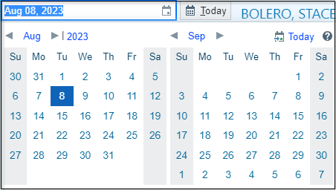 View scheduled patients for a specific day.
Department Folder – WHA NW Perinatal West
**Note: This does not change your login department! **
  - You can change the department here to view another clinic’s schedule.
  - To change your login department, click the arrow next to Log Out.
Click the arrow next to the WHA NW Perinatal West folder
Blue Folders – 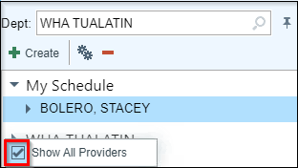 Ability to select specific schedules to view information.
Open folder and right click on ‘WHA TUALATIN’ then uncheck box to see only the providers who are in office that day.

My Schedule – Stacey (8 patients)
The patients with scheduled appointments on the schedule will show on the right. At the top right of the schedule, you can see the total # of patients, the last time the system refreshed itself, which is every 5 minutes, and a manual refresh (the... are you here yet... button).

All providers that could work in your department are now visible.
Now you can click on any provider listed and view their scheduled patients.

Schedule appointment information section
- Blank Column: To flag the patient’s name with colored dots. Dots are visual cues that a task is ready to be done.
- Blue dots: This happens automatically when a procedure is ordered (POCT, immunizations, clinic administered medications).
- Yellow dots: This happens automatically when outpatient labs are ordered (x-rays).
- Red dots: This is manually changed when the RN has completed their part of a MFM Telehealth visit.
- Status Column: Displays the status of the patient with any descriptors above, also displays exam room when the rooming staff
- Scheduled: Patient has an appointment with provider for that day scheduled.
- Present: Patient is in the building but may be busy completing paperwork, is not ready to be called back from the waiting room.
- Arrived: Patient checked in, and is ready to be called back to the exam room.
- Visit in Progress: Patient is in the room with MA or Provider.
- Checked Out: Patient checked out at the front desk after an appointment.
- Signed: Provider has completed documenting visit and sent to billing.
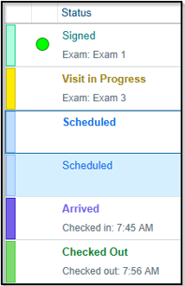
- Patient: Patient’s preferred name, age, and gender identity.
- Unanswered Questionnaires: Displays yes/no to indicate that the patient has unanswered history, series, and/or general questionnaires for an appointment.
- Same Day Visit: Displays an icon if the patient has any other appointments or cases scheduled on the same day as current visit.
- Meds Due Column: Red clock icon displays when Facility Administered Medications (FAM) are ordered. The icon hyperlinks to the MAR to document administration.
- Time: Scheduled start time of the visit.
- Type: Scheduled Visit Type (this can drive the different documentation tools, example: OB visit vs. GYN visit)
- Notes: “Why” the patient is coming in to be seen.

Report pane (right section of the window)
Single click the Gretchen patient to view the Report section.
The Preview Pane can be toggled on or off by clicking the Check box in the upper right side of the Schedule Workspace.
Click the drop-down arrow to change the position of the Preview Pane report.
Notice the Auto-position box is checked. To create more space to view the columns on the schedule, click the Bottom box. Now, there is more real estate to view the schedule and more information is easily visible.
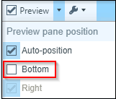
OB Snapshot is the default report – Has patient’s current information available in one report.
“Getting to know your patient is 60 sec. or less”
Each section contains current information and allows you to quickly jump into a specific area of the patient’s chart.
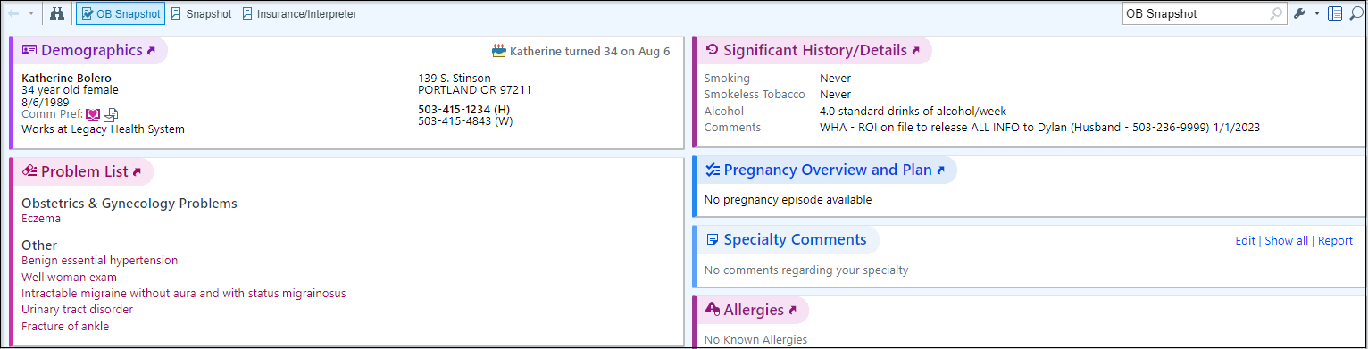

- Demographics – Patient Identifiers: Age, Sex, Address, Phone #’s, etc.
- Problem List – Patient’s current problem list.
- Care Team – View patient’s PCP and other Care Team Members
  - Examples: Social Workers, Nutritionist, and Behavioral Specialists.
- Health Maintenance – Care Gaps identified by patient’s age, sex, and documented problems.
- Vitals from encounters over the last 365 days – Saves time from having to jump into Chart Review just to find recent vital signs.
- Since Your Last Visit – Encounters with WHA
- Immunizations/ Injections – Documented Immunizations
- Preferred Pharmacies – Patient’s Preferred Pharmacy information.
- Medications – Patient’s current medication list.
- Allergies – Patient’s current documented allergies.
- Specialty Comments – Place to document specialty specific information (OB/GYN specific for WHA, example: Patient had a miscarriage on 1/3/2020)
- Significant History/Details – Tobacco and substance use history

Other reports are available that you may want to reference for different patients.
To make these reports as speed buttons on the report toolbar.
- On the far-right side, click the wrench.
- Click Add or remove buttons from toolbar button.
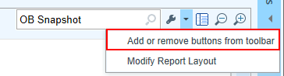
The first field has a Magnifying glass or what Epic calls a Selection Tool, this is a visual indicator that there is a list to select from. To shorten the list, type in the first part of the name of each report and press Enter to allow for quick selection.
Review the following Reports: These have been customized by clicking the wrench.
  - Pregnancy Episode – Summary of patient’s pregnancy episode
  - Snapshot Report – Summary of current documentation on the GYN patient.
  - Visit Orders – Way to view all orders and results from today’s visit.
  - Rooming Report – Report that displays Chief Complaint, Vitals and Notes that have been documented for the selected patient in today’s visit.
  - AMB facesheet – Demographics, Insurance information, PCP number, Contact information

Card Viewer
- Click Show Tasks button on the far right.
This is a section that allows you to view and take action on certain types of messages/ “Tasks” for:
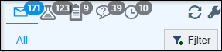
- All
- Results
- Communications such as Patient Calls, also known as Telephone Encounters.
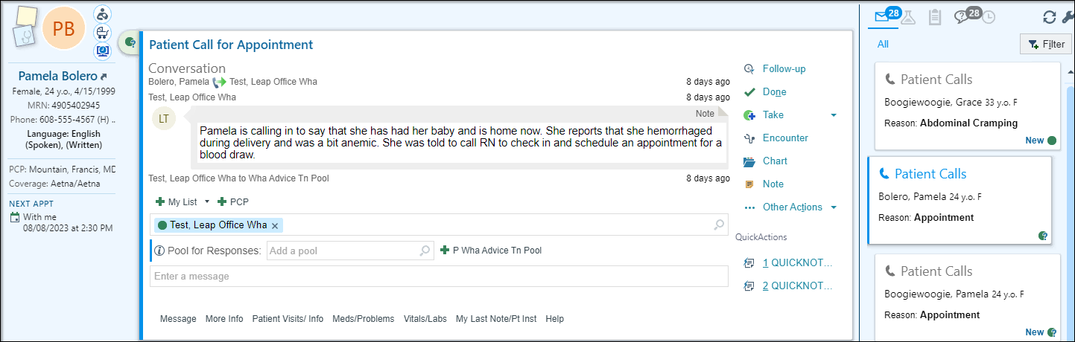
- Click Return to Schedule to collapse the section.
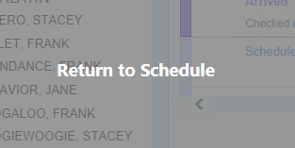

Module 3: Clinical Workflows

Exercise 1: Chart Review – Getting up to speed on your patient

Scenario: The Schedule shows that Paula is still Scheduled and is not present, therefore not ready to be called back from the waiting room. First, you will want to get up to speed on what is going on with the patient before she arrives.
1. Single-click on Paula name.

From the appointment notes, you see that she is coming in for an 8-week Postpartum Wellness and IUD Insertion.

2. Review the Snapshot report for this patient.

You see that she is due for some Health Maintenance.
- Next, click Chart above calendar.

The patient’s workspace tab opens. Epic allows you to have up to 4 patients’ charts open at the same time. To close click the X do not do this now.
Verify you have the correct patient’s chart open by reviewing information in Storyboard.
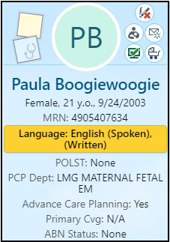
Storyboard
In a patient’s chart, Storyboard appears on the left side of the screen, and activity tabs appear along the top of the screen.
Hover over any item in Storyboard to see more.
Click information on the Storyboard to jump to an activity to see more detail or take action.
Click the back arrow to get back to where you were.
Use the Chart Search to find the information you’re looking for. For example, enter pap to search the patient’s chart for prior labs results.
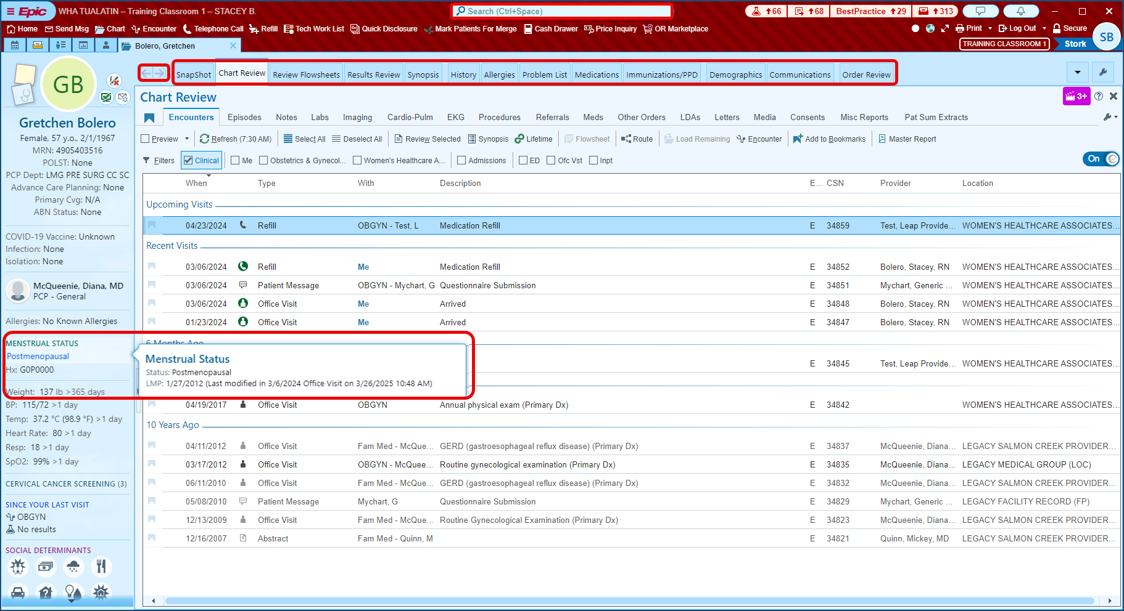
Storyboard presents information in layers. The general rule is, more basic information is towards the top and more specialized information is towards the bottom.
You can glance at it for basic answers to your questions, hover to see more information and click to take action.
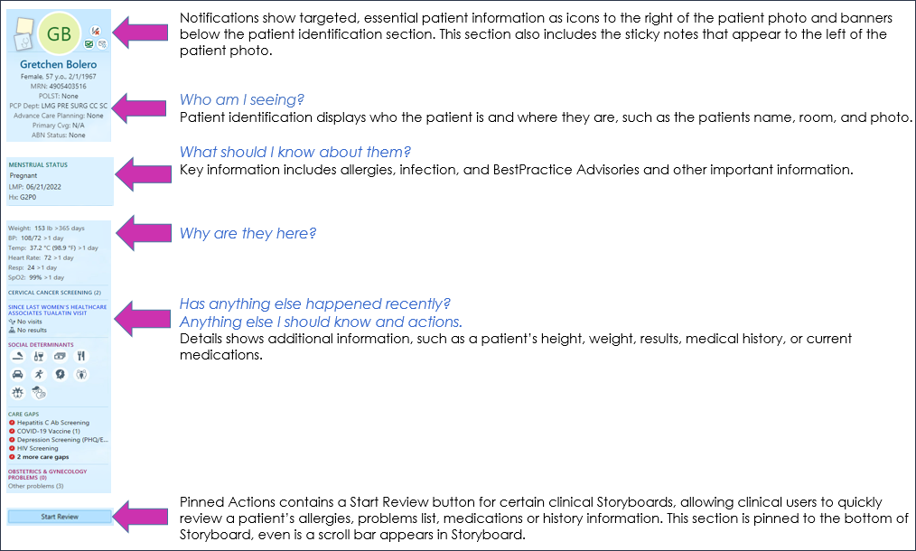
Create sticky notes  to leave reminders for yourself.
Suggestions are: hard to pronounce names, and/or big life events. Sticky notes appear in a floating window that you can minimize or close as needed. Note: A sticky note is a piece of the chart that no one else will see, unless directed to give a copy of chart for legal or court purposes.
Let’s add a note that she will be going back to school to finish her Master’s in Teaching.
- Click the blue Sticky Note icon  to leave a note in the patient’s chart that you and other providers in your specialty can see.
- Click the yellow Sticky Note icon 
- Drag the window down to an open section of the workspace.
- Type in note about Receiving masters in teaching.
**Note: It’s recommended to add dates to comments in this box. This will help keep a good timeline of what is going on in the patient’s life and make building rapport easier.**
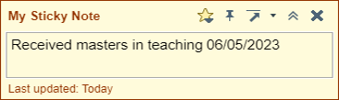
- Click the Chevrons to minimize, the X close the note entirely. Clicking the arrow moves the note to the upper right corner of the workspace or set a new home position. Clicking the Pin keeps the sticky note open in the patient’s chart. The Star has All Tools available such as spell check, SmartPhrases, SmartLists and more.
- Gray lines 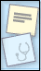 indicate there’s text in the sticky note. Hover to read the note or click to edit it.

To open Chart Review, click on Chart Review in the list of activity tabs.
Chart Review activity tab: 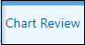
- Encounters tab: This section is where you can find all encounters, we have with the patient. This includes telephone, office visits, orders, patient emails.
- Locate the Last annual visit. (5 years ago, section)
  - Single click for Preview of report.
  - Double click to see the report in almost full screen.

There are Bookmarks and default filters that sort information by selecting or unchecking the checkbox.
- Episodes tab: Episodes are events to which services provided can be linked. Common uses for episodes are care management, worker’s comp, and, of course, pregnancies. Refer to the episode tab to see all services provided for a specific episode.
- Notes tab: Able to filter or view different note types separately, documentation from all encounters.
- Labs tab: All lab test orders and results from all encounters, procedure notes, op reports, etc.
- Imaging tab: All imaging orders and referrals (excludes external imaging orders
- Referrals tab: Where all referrals live, including external, internal, and referrals for external imaging (fax referral orders from here, but not imaging orders)
- Meds tab: Defaults to show patient’s Current Medications. Deselect to review all historical medications prescribed or documented in the chart.
  - Uncheck the Current Meds Only filter to see Historical Meds.
- Other Orders tab: Route external imaging orders from here after provider has co-signed them. Orders for Durable Medical Equipment (DME) reside in this tab as well.
- Letters tab: Epic generated letters printed or sent to patients are in this tab
- Media tab: All scanned documents and images uploaded into the patient’s chart. As documents get scanned, it is critical to add comments for searching capability.
- Consents tab: All documentation that has been electronically signed (i.e. consents)
- Misc. Reports: Allow you to review additional information:
  - Routing Hx,
  - My Chart Report (a report for all MyChart communications)

Now that I have shown you the long way to review a chart… Let me show you a
more efficient way to do so.

Locate the Epic Assistant bar under their name(in the hyperspace bar)
- Type UTI.
- Review the previous documentation.
- Hover to discover information.
- Click the X to close the workspace tab.

Module 4: Obstetrical Workflows

Exercise 1: MFM Consult, Initial Prenatal

Scenario: Christina is being seen for a consultation visit. She is newly pregnant and has Type 1 diabetes. She is excited to be pregnant for the first time and has arrived for her visit. Take a moment to read through the OB Snapshot report in the Preview Pane.

- Double click on Christina’s chart to open the encounter.
On the patient Storyboard you will notice an OB Sticky Note 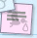icon, only available for pregnant patients that have active Pregnancy Episode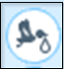. This note acts differently than the normal sticky note, this information is sharable amongst other clinical staff.

OB Sticky Note Activity: 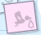
- Click the pink Sticky Note icon to leave a note in the patient’s chart that you and other clinical staff/providers can see.
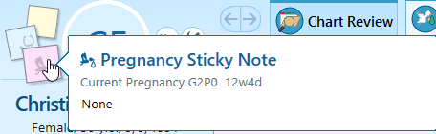
- Drag the window down to the open section of the workspace.
- Type in note.
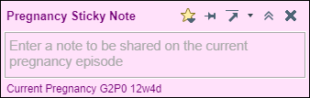
- Click the chevrons to minimize this note or the to close the note entirely. Clicking the arrow moves the note to the upper right corner of the workspace.
- Gray lines indicate there’s text in the sticky note. Hover to read the note or click to edit it.

Episode: 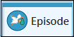
You will notice there are some different activities available for specific documentation for pregnancy.
Pregnancy Episode 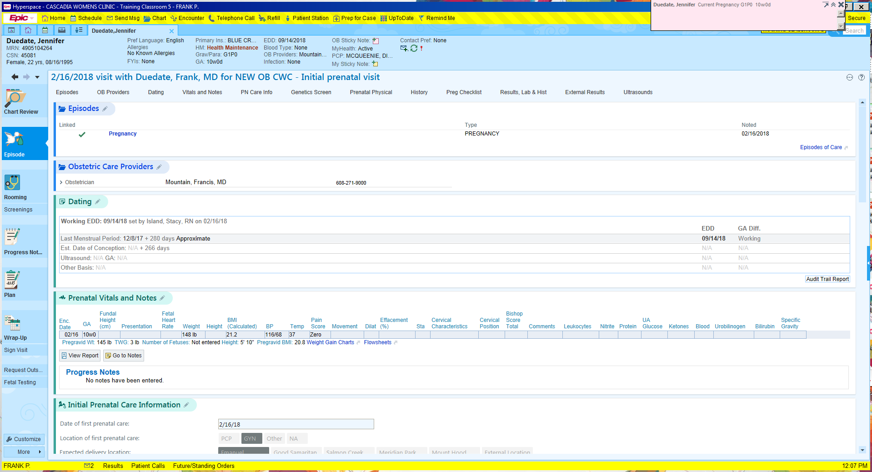
If Episode is not seen, follow the next 3 steps.
- Click the New Episode button.
- In the Name field, type WHA Maternal Fetal Medicine
- In the Type field, select Pregnancy.
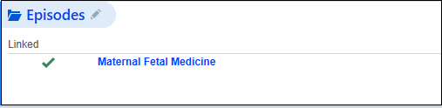

Section to document the Care Model for the patient. For this situation, you decide the appropriate Care Model should be NWP.
- In the Care Model field, click select NWP.
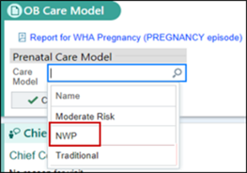
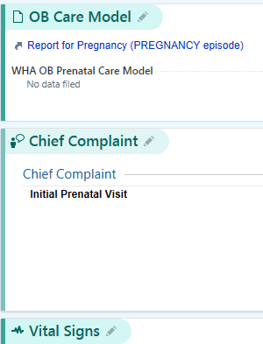
Note the reason the patient is being seen.
- Click the Chief Complaint activity to open the section.
- Use your speed button to select Initial Prenatal Visit.
- Click Close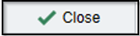

Multiple dating methods are available, but only one working EDD may be used. This information has been documented based off the patient’s documented Last Menstrual Period.

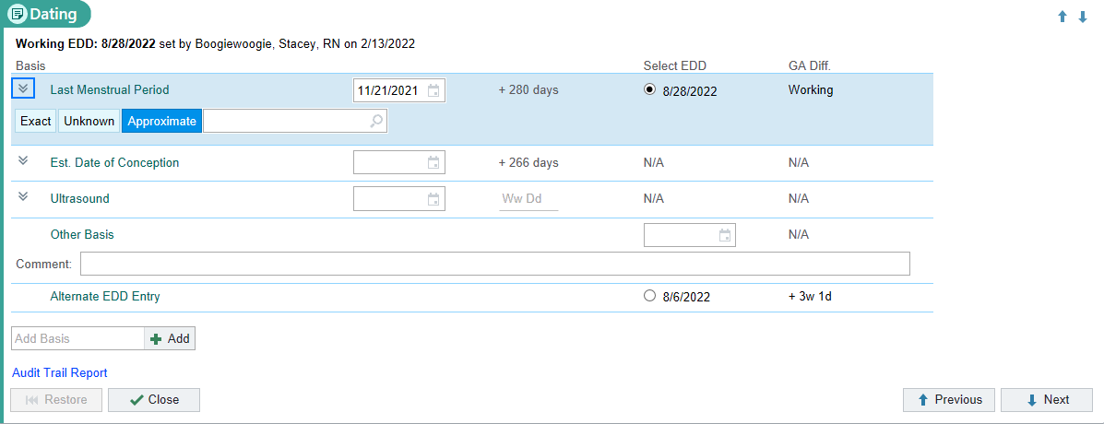

- Click the Dating section header to open the activity and view the Last Menstrual Period section.
- No information needs to be changed or updated. Click the Close button.


Now update with the rest of her vital sign information.
- BP: 108/70
- Site: Type L and press tab, to document the Left arm.
- Position: Type Si and press tab- select Sitting.
- Cuff size: Select the appropriate size for the patient.
- Pulse: 92
- Weight: 156lbs
- Height: 67in
- Temp:98.7
- Source: Oral
- Resp: 18
- SpO2: 98

Notice the OB/Gyn Status section has been updated with the documentation of her LMP and current pregnancy status from the Dating section.

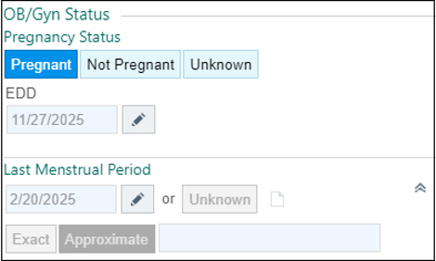

- Breastfeeding: Not Breastfeeding
- Click Mark as Reviewed

Notice the section has been updated with the documentation from the Dating section.
- Click Mark as Reviewed

Since Christina found out she was pregnant 6 weeks ago, she quit smoking.
- Click the Edit Tobacco Use link.
- Update the Smoking Status field, change to Former Smoker.
- Update the Quit Date field, type w-6.

Notice we are now in the History activity; continue to update Christina’s Alcohol and Drug Use.
- Update her Alcohol Use to say No.
- Click Mark as Reviewed
- Click the X to close the activity and return to other documentation.

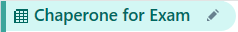

A chaperone must be provided to all patients who request one for sensitive exams.
- Click the pencil or the New Reading button.
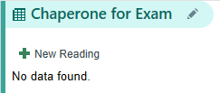
- Verify with the patient whether she would like to have a chaperone for her visit and click the corresponding button.
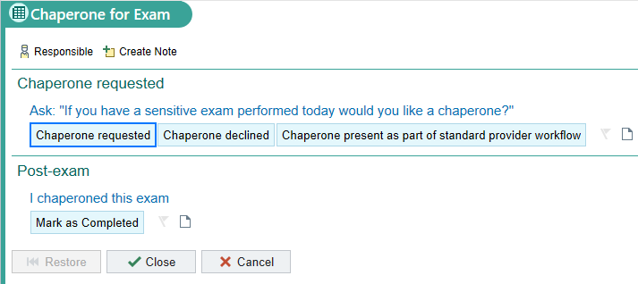

Christina has declined to have a chaperone present for her visit.
- Click the Chaperone Declined button.
- Skip the Post-exam section and click Close.


This section works together with the Pregnancy Checklist and Best Practice Advisories to help ensure patients receive the best care possible. You need to be checked and updated throughout the pregnancy.

For now, we will update what we know about the patient’s pregnancy so far.

- Number of Fetuses: 1
- Support Person: Romeo Montague
- Planned Delivery Location: Providence St. Vincent
- Acceptable Blood Products: All
- Planned Adoption: Not Applicable
- Click Close.

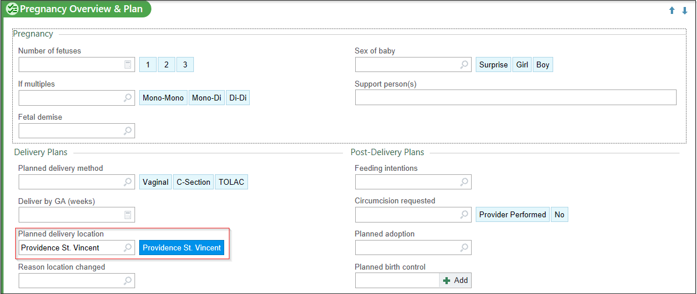


This section is where you could document Glucose and other lab information.

For now, I will document her pre-pregnancy weight, the number of fetuses (if known), and her height (this will automatically populate once added into the vitals section, if the box is blank type the patient’s height in).
- Click the pencil .
- Pregravid Wt: 145lb

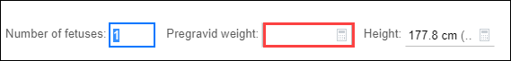

- Click Close.

The Pregnancy Checklist is a feature for support staff and providers to record what actions have been completed as a patient progresses through their pregnancy.

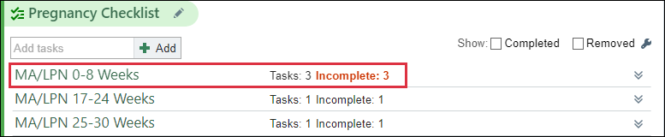

This patient’s checklist is incomplete, let’s review and complete some tasks.
- Using the chevron, open the MA/LPN 0-8 Weeks.
- Review each task with the patient.
- Check the box when complete.

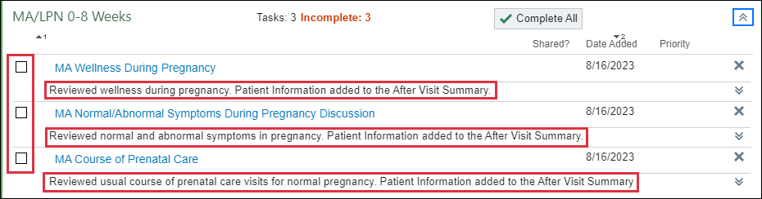

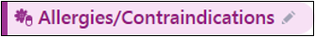
Verify that the Allergy list is correct and that she is not allergic to anything that she is aware of; which she confirms.
- Click the Mark as Reviewed 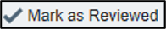 button.

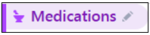
Notice that Christina has the Fred Meyer on Martinazzi Ave pharmacy documented in the system but states she now goes to Walgreens.
- Click the Pharmacy button
- In the Name field, type Walgreens
- In the City field, type Beaverton
- Click Search.
- Patient verifies it is on SW Murray Scholls Dr., click the star to add to preference list.
- Click Accept to save the changes.

Patient states that she has recently started taking Iron. Documenting here will add this to her current medication list for reconciliation in the future; does not allow for refills.
- In the Add Medication field, type Ferrous Sulfate and press Enter.
- No options…. Click the Database Lookup tab to search the full system.
- Select the option FERROUS SULFATE 325 MG (65 MG IRON) ORAL TBER.
- Click Accept.
- Update the Med List Status: click the arrow and select, Best possible list obtained
- Click the Mark as Reviewed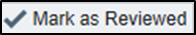 button.

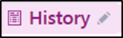
You will need to update section within this navigator activity.
- Open the section by clicking the pencil in the section header.
Notice that her first pregnancy information is not complete. Let’s take a moment to update this with our Christina patient.

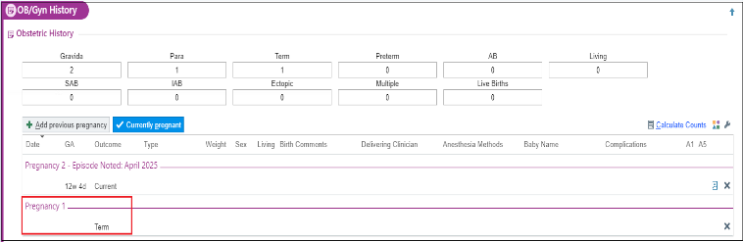

- Double click into the first pregnancy.
- Fill in as much information you can gather from the patient.
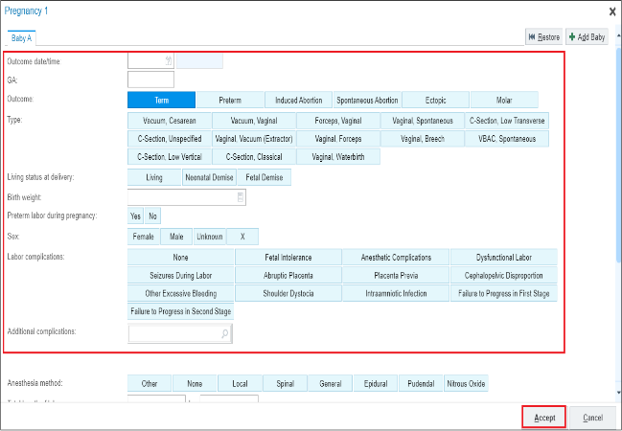
- Click Accept.
- Click Calculate in the OB History section to fill in the blank boxes.
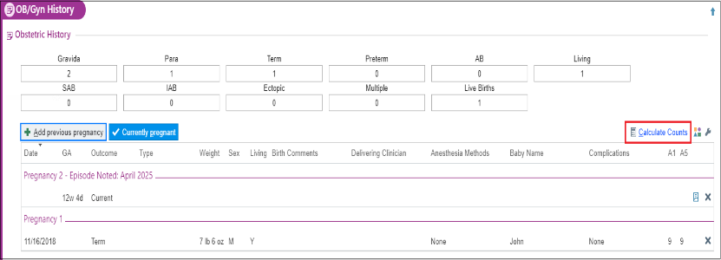
- Click Mark as Reviewed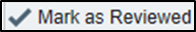.

Medical History
- Confirm that no changes need to be made in the Medical History Section.

Surgical History
- Confirm that no changes need to be made in the Surgical History Section.

Family History
- Confirm no changes need to be made in the Family History Section.

Sexual Activity
- Confirm any changes to this section.
- Click the Mark as Reviewed button at the bottom of the history section.
- Click Close.


This is a section to document care team providers for this specific patient, such as: Obstetrician, Midwife, and later in the pregnancy noting the Pediatrician. Is there anything we need to do here for this visit? No

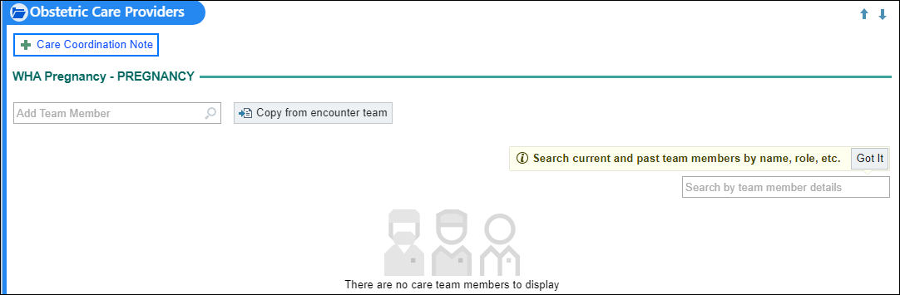

The patient’s Edinburgh Depression Scale Score is seen here since she completed it online. Is there anything we need to do here for this visit? No

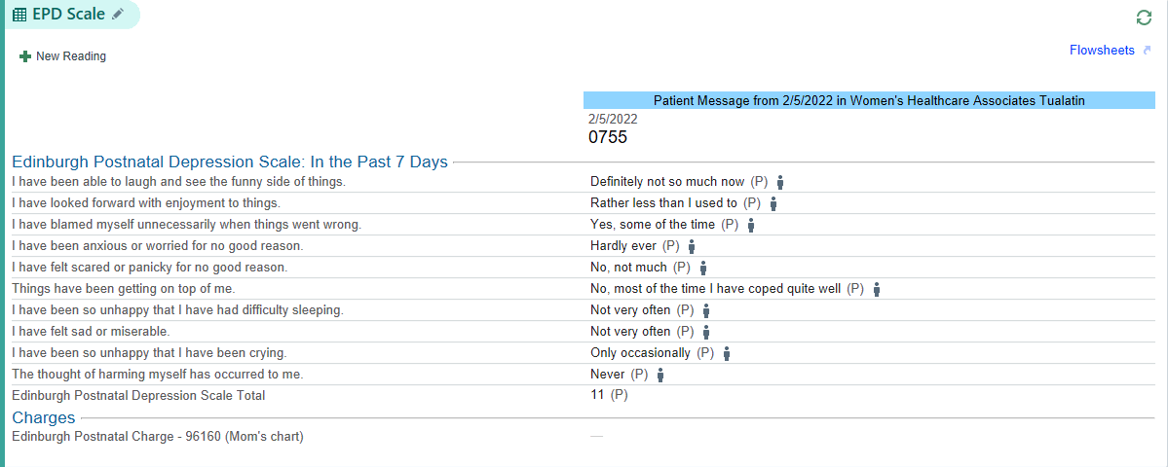


The purpose of this section is to document the Genetic Screening information for the Birth Mother and Father.

- Click the section name to open for documentation.
- Ensure the first question is answered.

- Click the Set all to No button (top right) 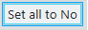
  - If applicable, make any changes before closing the section.

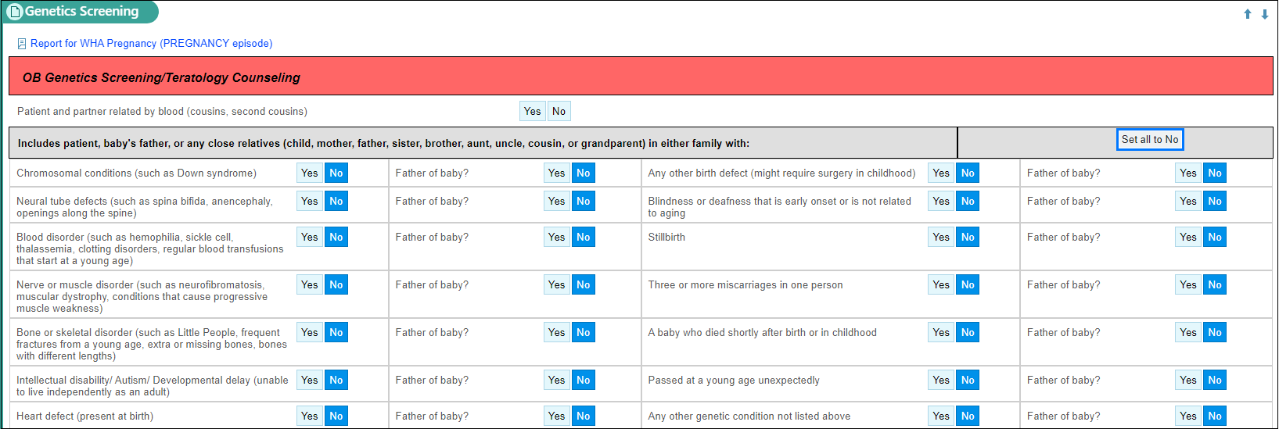
- Indicate whether the patient has completed any health based genetic testing or not, such as: genetic cancer panels, 23andMe, or other genetic carrier screening.

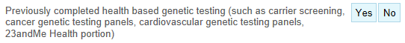

  - If Yes, document in the Details box.
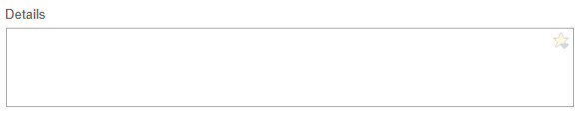


The patient has brought in documentation from an outside lab showing a positive result to a pregnancy blood test.
- Click New Reading button.

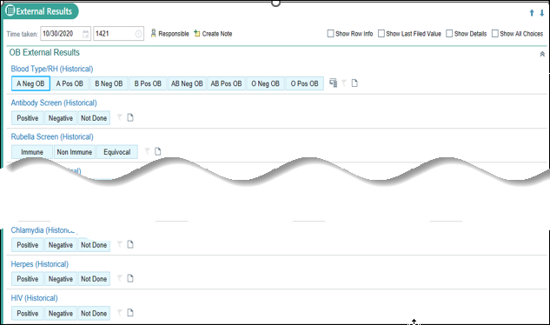

- The result was done 1 week ago, In the Date field , and type w-1.
NOTE: Always put the correct date in FIRST. Once it is entered, you cannot go back and change.
- In the Labs other section, type in HCG – Serum
- Add Comment  of 13,000
- Click Close; repeat if necessary, to show appropriately in the flowsheet.

Progress Note: 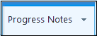
There are several features that streamline documentation. You may use a Smartphrase or simple free text in your note.
- Find Create Note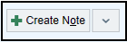.
- Using drop-down arrow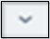 select Blank Note.
- Place you cursor in the white space, type; Here for MFM consultation for Type 1 diabetes in pregnancy at 12 0/7 weeks. Recent HgA1c 6.2.
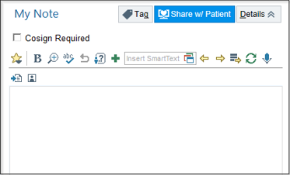
This Visit: 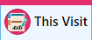
This Visit is where the Visit Diagnosis and Problem List live in the chart. Visit Diagnosis can be a symptoms/reason that the patient is having a lab or procedure done.

It is decided that Christina will continue her care with NWP for the duration of her pregnancy. The MFM providers will document this in the Care Coordination Note using the hyperlink in the Problem List.
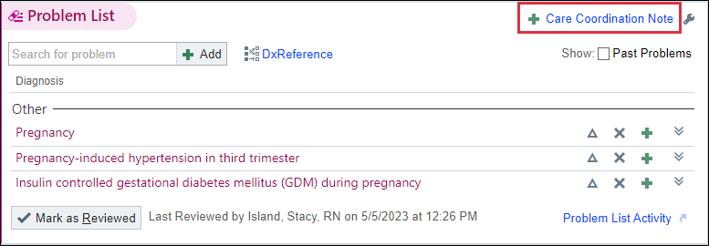
You will be able to see the Patient Care Coordination Note in the snapshot report section under you clinical schedule.
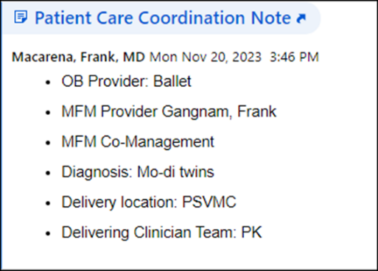

MFM providers historically add to the Patient Instructions.

Due to the complexity of patients seen at Northwest Perinatal, the clinician adds when her next appointment is needed.

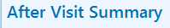
I will now preview the AVS.
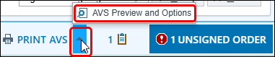
- Click AVS Preview and Options to make changes to the Font Size or language as needed.
- Click on secure before leaving the exam room.

Exercise 2: Return Prenatal Visit w/NST Documentation

Scenario: Odette is here for her return OB visit and antenatal testing, Non-Stress Test (NST) performed in clinic.
Use some of the reporting tools to get up to speed with your patient.
- Click the WHA OB Prenatal Checklist Report on the bottom report pane
- Double click to open the patient’s visit encounter.

Episode:

Note the reason the patient is being seen.
- Click into the Chief Complaint text box.
- Type: Routine Prenatal
- Click Accept.

Add another chief complaint for the NST.
- Type: Hypertension
- Press Enter, using your keyboard.
- Click Accept.
- Click Close.
Now update with the rest of her vital sign information.
- BP: 134/86
- Site: Type L and press tab, to document the Left arm.
- Position: Type Si and press tab- select Sitting.
- Cuff size: Select the appropriate size for the patient.
- Pulse: 72
- Temp:98.6
- Source: Oral
- Weight: 156lbs
- Height: 64in
- Resp: 14
- SpO2: 99
- Click Close.

- Click the pencil or the New Reading button.

Odessa has requested to have a chaperone present for her visit.
- Click the Chaperone Requested button.
- Skip the Post-exam section and click Close.

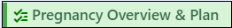

We need to update the Overview and Plan for this patient. It has not been filled out incrementally as it should have been throughout her pregnancy.

- Use your clinical judgement to complete this section.

Document the OB urine dip and fetal movement.
- Click the Date of visit hyperlink.

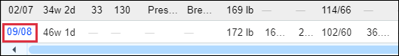

- Fetal Findings - Fetal Movement: Present
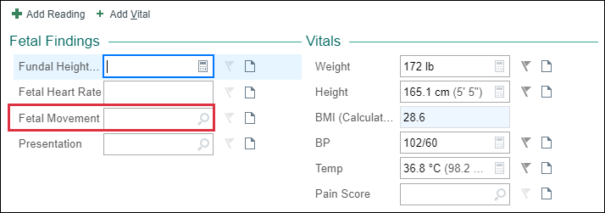

- UA - Protein: 1+ (30)
- UA - Glucose: Normal

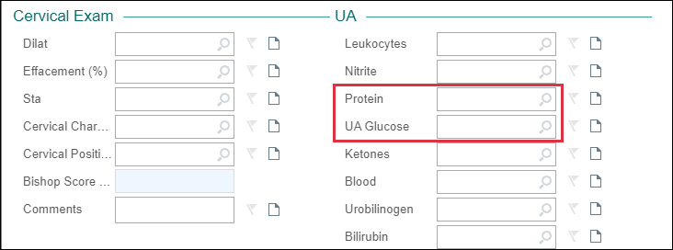

- Click Accept.
Verify with Odette that her allergy list is correct and that she is still not allergic to anything. She confirms No Know Drug Allergies (NKDA).
- Click the Mark as Reviewed button.

- Verify that Odette’s Pharmacy is still the correct pharmacy.
- Mark her medications as Taking, Not Taking, Taking Differently or Unknown.

- Update the Med List Status: click the arrow and select, Best possible list obtained
- Click the Mark as Reviewed button.
- Click Close

Progress Note:
There are several features that streamline documentation like using a smartphrase.
- Find Create Note.
- Using drop-down arrow select Blank Note if not seen.
- Place your cursor in the white space, type; Patient here for OB visit. Reactive NST today. Odessa reports fetal movement, no bleeding, loss of fluid, or regular contractions. BP stable.
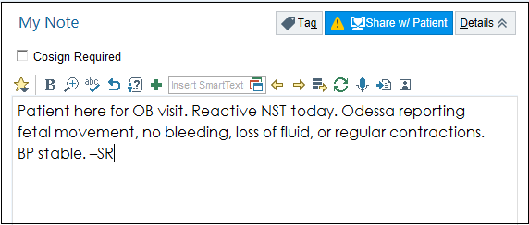
This Visit:

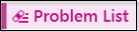
If the Gestational Hypertension problem lives in the Problem List, it can be moved to the Visit Diagnosis without having to search for it when you click the green plus sign.
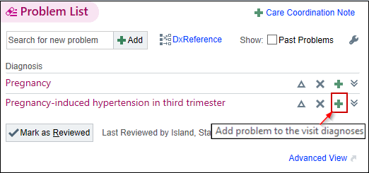
Due to Gestational Hypertension, you know an NST will need to be completed prior to the provider coming in the room with the patient. Go to the fetal testing activity located in the right-side activity tabs section.

Fetal Testing Activity: 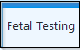

Navigate to the Fetal Testing activity and document a New Reading. The Charges $ will drop when the provider results the NST as reactive or non-reactive.

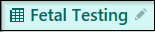

- Click New Reading button.
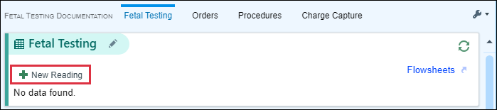

You need to add the Gestational Diabetes as an additional NST Reason. The only option is Diabetes Mellitus, so you need to use the piece of paper to make a comment.

- Check the Other (Comment) and the Gestational Hypertension boxes.
- Click on the paper on the right-hand side of the screen.
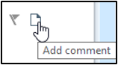
- Type: Gestational Diabetes in the NST Reason box.
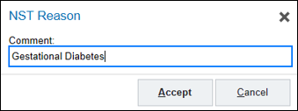
- Click Accept.
- Scroll down to the bottom of the NST form.
- Click Close.

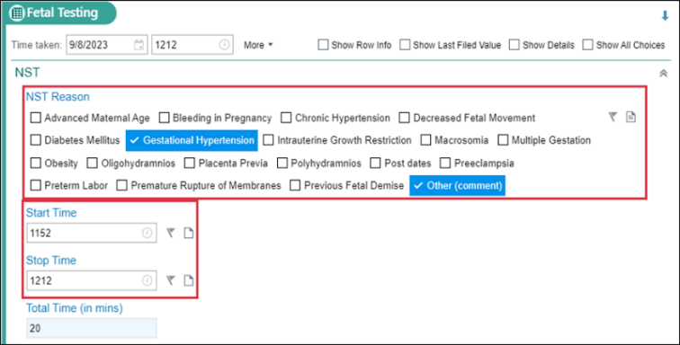

- NST Reason: click the Gestational Hypertension
- Start Time: type; n, then press Enter on your keyboard
- Stop Time: type; n+20, the press Enter on your keyboard
- Baseline Rate: 150
- Variability: 6-25BPM
- Decelerations: None
- Accelerations: 15x15
- Contractions: irregular
- Movement: Present
- Acoustic Stimulator: No
- $ Result: Reactive
- NST Interventions: Document that you repositioned the patient and you’re notifying the provider.
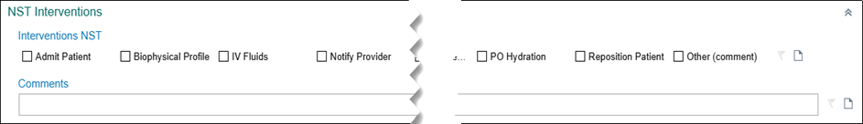

Progress Note:
NST documentation to the note is nuanced with NWP. See the guide below:
- When patient is seeing Mod-risk MD – it is built into note template. When you complete your documentation under fetal testing, the discrete data will pull in automatically when the note template is refreshed.
- When patient is seeing MFM – they have their own smartphrase they pull into their note template.
- NST only visits – you will add a smartphrase to a note template.
For this exercise, Odessa is seeing an MFM today.

- Place your curser at the top of a Blank Note.
- Complete your documentation using your clinical judgement
Next, we need to Wrap Up her visit.

This Visit:
MFM providers historically add to the Patient Instructions.

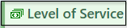

Level of Service is where clinicians add billing for the visit.

Due to the complexity of patients seen at Northwest Perinatal, the clinician adds when her next appointment is needed.

Another part of Meaningful Use measures is to give the patient a copy of today’s visit.
Preview the AVS.
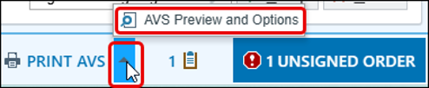
- Click on secure before leaving the exam room.

Exercise 3: Pre-Charting
When the patient’s appointment status has not changed to Arrive and is still displayed as Scheduled, it will allow you to access the visit encounter through a “Pre-Charting” option. This allows you to document ahead and spend more time with the patient.
- Double click on your patient, Odessa’s, chart.
You have limited sections to document, Notice the pre-charting information box. Pamela is not Arrived; therefore, you should NOT click start the visit.

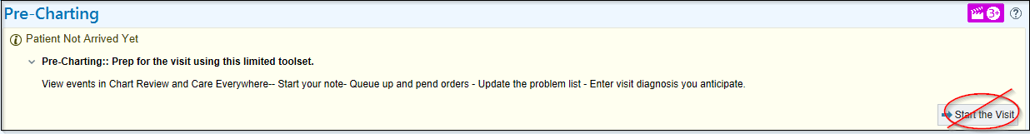

Progress Notes Activity:
For this exercise, Your Odessa patient will be seen by a mod-risk provider later today
- Find Create Note.
- Using drop-down arrow, select WHA MODRISK ON VISIT
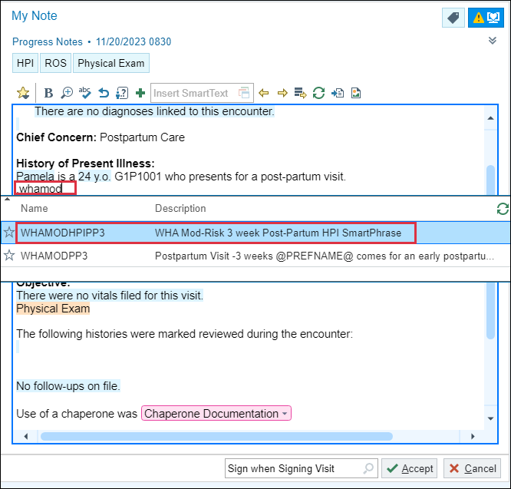
Fill in as much historical information as you can when appropriate.

Pre-Charting: 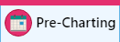

In this section, you can add the Visit Diagnosis, Patient Instructions and review the Problem List as appropriate for the visit. The Problem Lists are managed by the providers only in most cases.

There is nothing more for you to do.

- Click the X to close out of Odessa’s chart.

Exercise 4: MOD Risk Return Prenatal Visit

Scenario: Jenna is being seen for a MOD Risk follow-up visit.
Use some of the reporting tools below your schedule to get up to speed with your patient.

- Click the WHA OB Prenatal Checklist Report on the bottom report pane
Now let’s double click on our Jenna patient to open her visit encounter.

Episode:
Note the reason the patient is being seen.
- Click into the Chief Complaint text box.
- Type: Hypertension
- Click Accept.

Capture her vital sign information.
- Open the Vital Sign section
- BP: 134/86
- Site: Type L and press tab, to document the Left arm.
- Position: Type Si and press tab- select Sitting.
- Cuff size: Select the appropriate size for the patient.
- Pulse: 72
- Temp:98.6
- Source: Oral
- Weight: 184lbs
- Height: 64in
- Resp:
- SpO2:

Jenna has requested to have a chaperone present for her visit.

- Click the Chaperone Requested button.

Document fetal movement and clinic urine dip.
- Open Prenatal Vitals and Notes
- Fetal Movement: Present
- Protein: 1+
- Glucose: 2+
Verify with Jenna that her allergy list is correct and that she is still allergic to Amoxicillin and review her medications.
- Open the Allergy activity
- Click the Mark as Reviewed button.
- Go to the Medications activity.
- Verify that Hermiston Drug & Gift is still the correct pharmacy.
- Mark her medications as Taking, Not Taking, Taking Differently or Unknown.
- Update the Med List Status: click the arrow and select, Best possible list obtained
- Click the Mark as Reviewed button.
- Click Close

Progress Note:
If you have completed Exercise 3 [Pre-Charting], skip steps 30 and 31 and proceed directly to step 32 to document in the RN note.
- Find Create Note.
- Using drop-down arrow, select WHA MODRISK ON VISIT
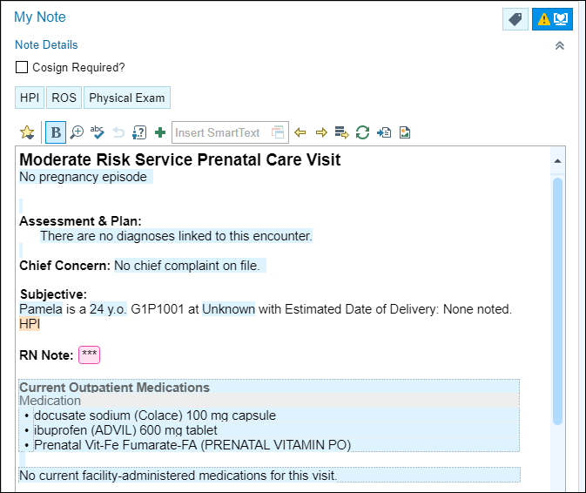
- Click next to RN note found in the template and type; BPP today. Patient denies any vaginal bleeding, LOF, or regular contractions. Home BP value is consistent with manual cuff in office. Endorses good fetal movement. She has weekly OB checks/antenatal testing scheduled out until xx/xx. –your initials

This Visit:
Next, we need to Wrap Up her visit with us.

Due to the complexity of patients seen by Mod Risk, the clinician adds when her next appointment is needed.
Preview the AVS.
Click on Secure before leaving the exam room.

Exercise 5: 3 Week Postpartum Telehealth Visit

Scenario: Pamela is being seen virtually for her 3-week postpartum visit.

Double click on Pamela’s appointment to open the pre-charting activity.
It will bring you into pre-charting. You have limited sections to document: Visit Diagnosis, Problem List, Medications, Orders, Patient Instructions and Notes.

If your patient delivered at a Providence Facility, you will need to go into the history activity and reconcile the delivery within the Obstetrics section. This allows all discrete data to flow into the note once the recent pregnancy is reconciled. This cannot be duplicated in training, but will be an important step once in the live environment.

**NOTE: The following two screenshots are just for FYI to show you what it would look like.**

In the OB History section, you will click on Start Reconciliation.
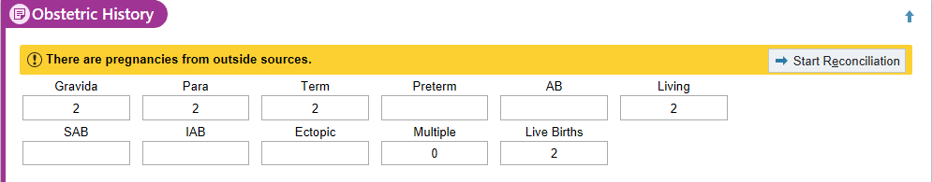

Select the pregnancy you wish to reconcile, click the Merge button, and then click accept.
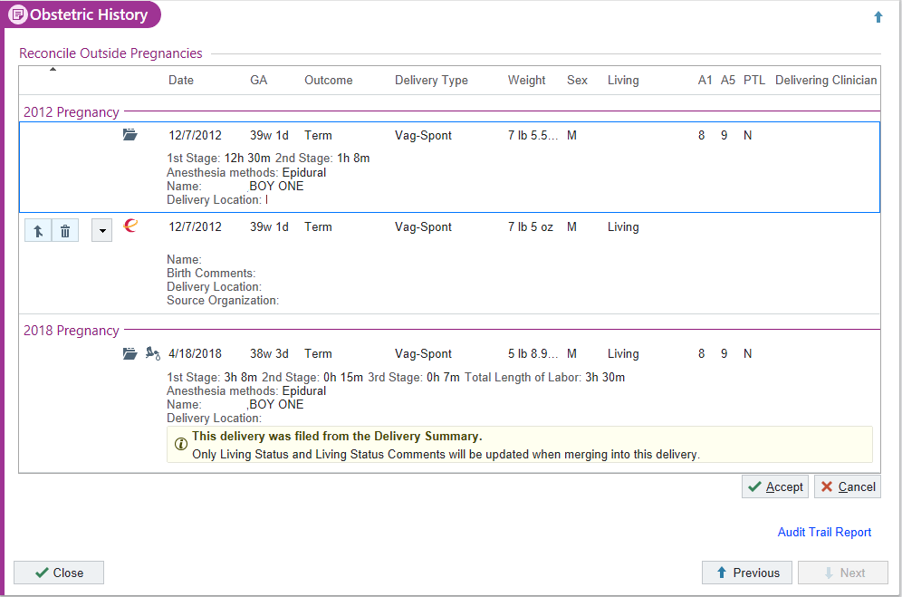

Let’s complete some pre-charting before we get Pamela on the phone. First we will pull in our Note Template for Pamela’s postpartum visit.

Progress Notes Activity:

For MFM telehealth visits, you will use a blank note template and add a smartphrase.
- In the My Note section, place your curser in the white space under History of Present Illness and single click using your mouse.
- Type: .NWPMFMTELEHEALTH
- Press Enter on your keyboard or double click the smartphrase you need

Fill in as much historical information as you can. You will fill out the rest of the information once you have reached Pamela on the phone.

You will want to review Pamela’s Delivery information in Chart Review.
Chart Review Activity

Review the 1-week Postpartum Telephone Encounter, if one was completed, and her admission to the Midwifery Birth Center (including the Delivery Note). Document any important or pertinent information into the note. Make sure to clarify and questions once you have the patient on the phone.

Pre-Charting:

Let’s call Pamela to start the rooming process.

In her appointment notes (the Notes column on the schedule) will be the phone number for you to contact her at.

When Pamela answers the phone, you need to verify you have the correct patient by obtaining at least two to three pieces of identifying information from her.
You can view this information under Demographics in the Snapshot Report.

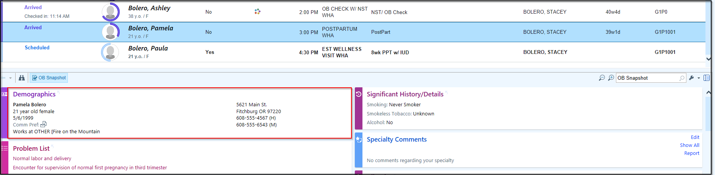

- Verify patient’s Name, DOB, and/or address in Demographics.

Once you have verified you have the right patient, we can continue the check-in process.

- Click on the icon at the top of the schedule navigator.

The Check In activity opens.

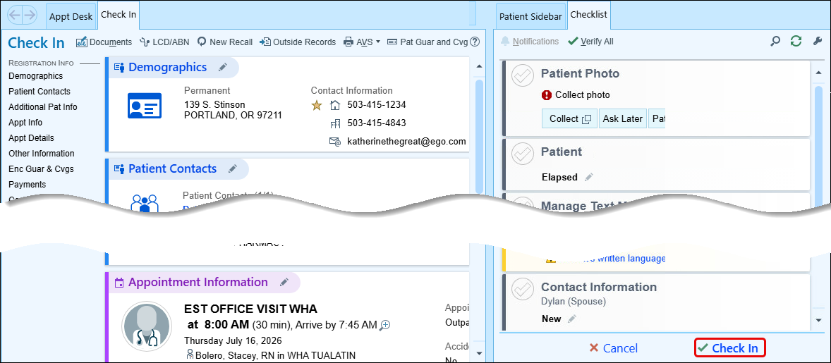
- Since the patient has already been verified, click in the bottom right corner of the screen.
- Click Continue Anyways on the confirmation message.
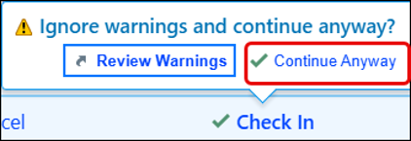
- Click Cancel on the next pop-up window since you will not need labels printed for this patient.

You will be brought back to the schedule and can now see that Pamela is checked in for her appointment.

Double Click on Pamela’s appointment to open the Encounter.

Episode Activity:

Ask the patient for vitals over the phone and document accordingly if they have a BP cuff at home or if they took their weight that day. Not all patients will have this information and therefore this section could be left blank.

- Open the Vital Signs activity.
- BP: 116/74
- Document a comment using the piece of paper “obtained over the phone with RN”
- Weight: 160lbs
- Document a comment using the piece of paper “obtained over the phone with RN”

Verify Pamela’s Tobacco Use.

- Verify status with patient.
- Click Mark as Reviewed.

Update Pamela’s OB/GYN Status.

- Pregnancy Status: Not Pregnant.
- Menstrual Status: Recent Pregnancy.
- LMP: Auto populates from LMP prior to pregnancy.
- Breastfeeding: Breastfeeding
- Click Mark as Reviewed.
- Click Close.

Since Pamela is a Postpartum Patient we must enter information into the Postpartum Info section of her chart. This will also pull discrete data into the note.


- Click New Reading 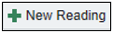
- Ask Pamela the following questions over the phone and document the following:
  - Baby Name: Delphina
  - Baby Weight: 7lb 9oz
  - Delivery Date: [insert date from her L&D Delivery Note]
  - Delivery Method: SVB
  - Feeding Method: Breast
  - Lactation Visit: Yes
  - Lochia Amount: Small
  - Voiding: Normal
  - Stools: Normal
  - Intercourse: No
  - Hemorrhoids: None
  - Incisions: Laceration
    - Comment: 1st degree perineal
  - Current Contraception: Abstinence
  - Pain: skip, patient states no pain
- Go over Healthcare Follow-Up.

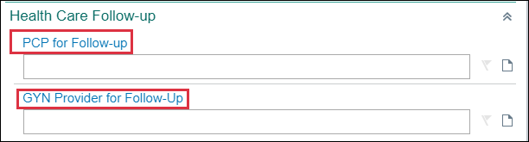

- Click Close

Notice that some activities are not available on the Episode tab. Pamela is post-partum so some things will need to be documented in the rooming tab.

Rooming Activity:

This activity is where you document the “intake” information for the patient.
Document the reason the patient is being seen today.

- Click the Chief Complaint to open the section.
- Click the Post-Partum Care speed button.
- Select Close at bottom of section.

Verify that Pamela’s Allergy list is correct and that she is allergic to Cephalosporin and had no additional allergies.

- Click the Mark as Reviewed button.
- Click Close.

Pamela states she is taking her medication, and that she picks up her prescriptions at Hermiston Drug & Gift – Hermiston, OR – 114 East Main Street.

- Verify the Pharmacy is correct
- Verify that Pamela is taking the Colace, Ibuprofen, and prenatal vitamins and mark as Taking.
- Verify that Pamela is still using her Breast Pump and mark as Taking.
- Update the Med List Status: click the arrow and select, Best possible list obtained.
- Click the Mark as Reviewed button.
- Click Close.

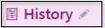

History needs to be reviewed and verified so that we have the correct information documented for meaningful use.

No changes for Pamela at this time, but you notice that her OB history has some blank boxes.

OB History

- Pamela has one pregnancy listed.
- Click the Calculate Counts button to update your G&P History.

Medical History
- Click on the chevrons to the far right of the screen to close your quick entry sections.
- Confirm that no changes need to be made in the Medical History Section.

Surgical History
- Click on the chevrons to the far right of the screen to close your surgical history quick entry sections.
- Confirm that no changes need to be made in the Surgical History Section.

Family History
- Confirm no changes need to be made in the Family History Section.

Sexual Activity
- Click Abstinence.

Confirm no changes to the Alcohol, Drug, Tobacco, and Vaping section. Scroll down the end of the History Section.

- Click Mark as Reviewed.
- Click Close.
Now you can go back into the progress note and complete the HPI section.

Progress Notes Activity:

Finish completing your documentation with the patient under the RN Note.

Send chart to trainer:
- Enter Stacey Bolero in 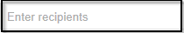
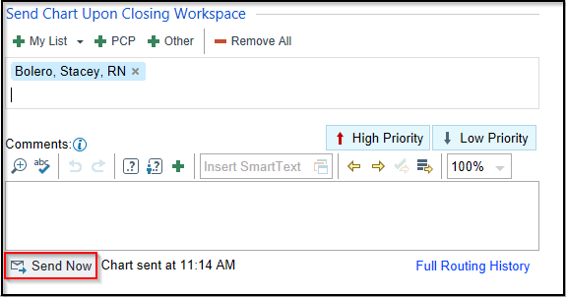
- Click Send Now.

Before securing your workspace, we must let the provider know that she’s ready.
- On the schedule, change to a Red flag .
- Return to the encounter by clicking the patient’s name

Module 5: Other Clinical Workflows

Exercise 1: Nurse Visit for Insulin Teaching

Scenario: Camille was seen earlier this week with an MFM who recommended a nurse visit with an RN. She is on the NWP west nurse scheduled today for diabetes teaching.

- Go to NWP West Nurse, WHA schedule located under the NW PERINATAL WEST department.

You can see that she has Arrived. Double click on her appointment from your schedule.
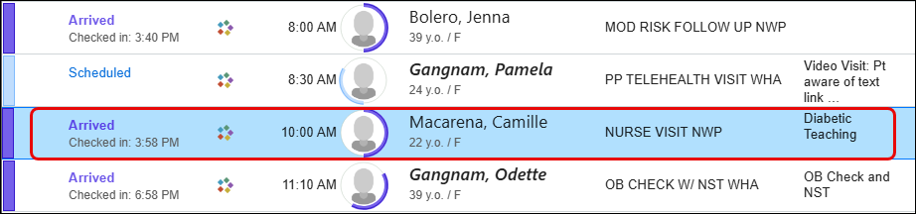

Episode:
Note the reason the patient is being seen.
- Click into the Chief Complaint text box.
- Type: Diabetes Type 1.
- Click Accept.

Capture her vital sign information as necessary.

- BP: 106/66
- Site: Type R and press tab, to document the Right arm.
- Position: Type Si and press tab- select Sitting.
- Cuff size: Select the appropriate size for the patient.
- Pulse: 88
- Temp:98.3
- Source: Oral
- Weight: 156lbs
- Height: 64in
- Resp: 16
- SpO2: 97

Verify with *** that her allergy list is correct and that she is still allergic to Amoxicillin.
- Click the Mark as Reviewed button.

The provider is sending her insulin prescription to her pharmacy for pick-up after the nurse visit with you.

- Open the Medications activity.
- Verify that Hermiston Drug & Gift is still the correct pharmacy.
- Mark her Prenatal vitamins as Taking
- Update the Med List Status: click the arrow and select, Best possible list obtained.
- Click the Mark as Reviewed button.
- Click Close.

Progress Note:
- Find Create Note.
- Using drop-down arrow select Blank Note if not seen.
- Place your cursor in the white space, type; .NWPINSULINTEACHING
- Select Insulin Teaching.
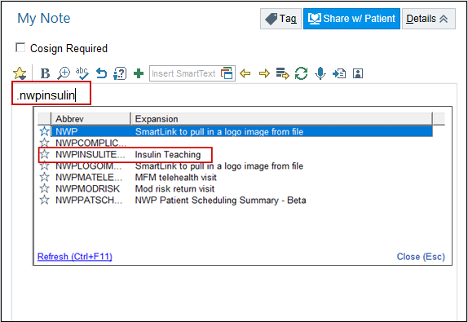
- Using F2, complete all the variables/wildcards.
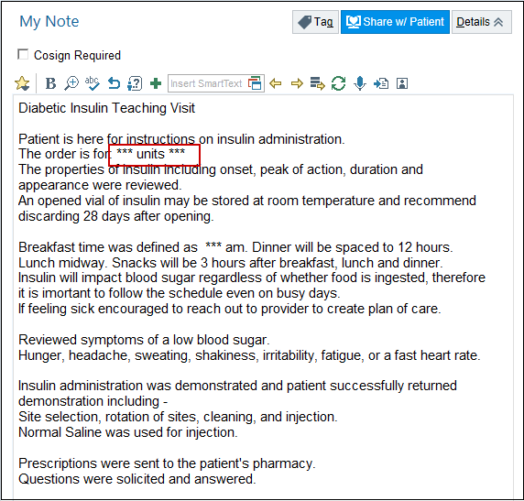
For this exercise, let’s say that our Camille patient had a nurse visit only today. You will need to enter a Level of Service and Sign the visit.
Let’s practice entering a No Charge Nurse Visit for billing.

- Go to LEVEL OF SERVICE located in your bottom task bar.
- Click on RN visit.
- For training, you will also need to add an Authorizing Provider (Auth prov).
- Type; your Frank provider.
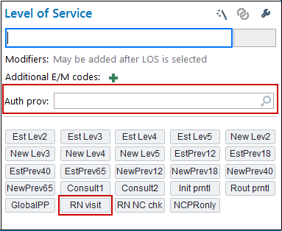
Now that you have completed all your documentation it is time to sign the visit.
- Click Sign Visit.

Exercise 2: Nurse Visit & Clinic Administered Medication Documentation

Scenario: Rachel is on the NWP West nurse scheduled today for a Rhogam injection and has an interpreter on the phone with her.

- Go to NWP West Nurse, WHA schedule located under the NW Perinatal West department.

First, let’s arrive our Rachel patient by single clicking on her appointment from your schedule.
- Click on Check In located in the schedule activities found above the schedule.
The Check-In window opens.
- Since the patient has already been verified, click Check In in the bottom right corner of the screen.

A Confirmation Message bubble opens on the bottom right of the screen.

- Click Continue Anyways on the confirmation message.
- Click Cancel.

You will be brought back to the schedule and can now see that Rachel is checked in for her appointment.

Now double click the patient’s visit to open for documentation and add the interpreter documentation.

Interpreter Documentation Activity:

- Click the Needs Interpreter banner to open the Interpreter Documentation activity.

An Interpreter window opens.
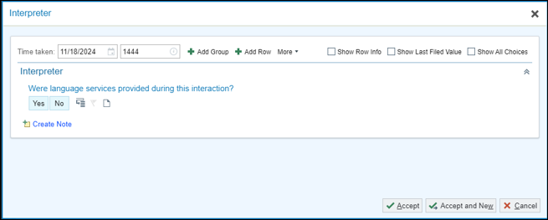

For Rachel’s appointment, document that you did use a telephonic interpreter from Linguava named Carrie Smith who is not OHA Certified.

- Were language services provided during this interaction? Yes.
- Interpreter/Bilingual Staff/Visit provider: Professional Interpreter
- Interpreter/Bilingual Staff/Visit Provider Full Name: Carrie Smith
- Interpreter Mode: By Phone
- Interpreter Service/Agency: Linguava
- Is the interpreter certified or qualified through the Oregon Health Authority? Not Certified /Qualified by OHA.
- Click Accept once documentation is complete.
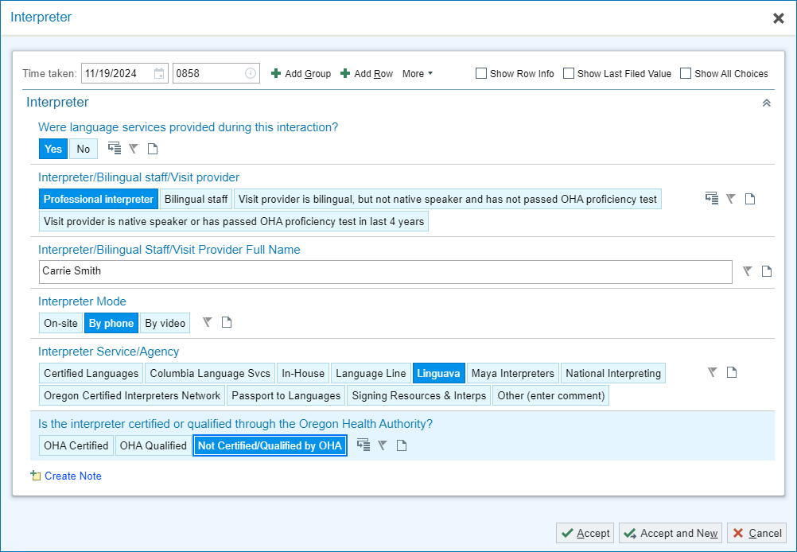

Episode Activity:
Rachel states she is here for a Rhogam Injection.
- Go to the Chief Complaint activity
- Type and select Injection
- Close the activity.

I will now move on and update the chart with Rachel’s current Vitals taken today if applicable.
- BP: 110/74
- Site: Left arm.
- Position: Sitting.
- Cuff size: Type Ad and press tab- select Adult.
- Pulse: 66
- Temp: 98.2
- Source: Oral
- Weight: 180lb
- Height: 67in
- Resp: 17
- SpO2: 99

For Meaningful Use, verify Rachel’s Tobacco Status.
- Click Mark as Reviewed

I also need to verify that Rachel’s Allergy list is correct and that she is not allergic to anything new that she is aware of.
- Click Mark as Reviewed

Verify where she likes to pick up her prescriptions (same pharmacy), and what medications she is currently taking.
- Update Med List Status: Best possible list obtained.
- Click Mark as Reviewed.

This Visit:
- Go to Problem List
- Locate Rh Negative status during pregnancy under the list of problems.
- Click on the Green Plus .
- To satisfy ICD-10 requirements, select third trimester.
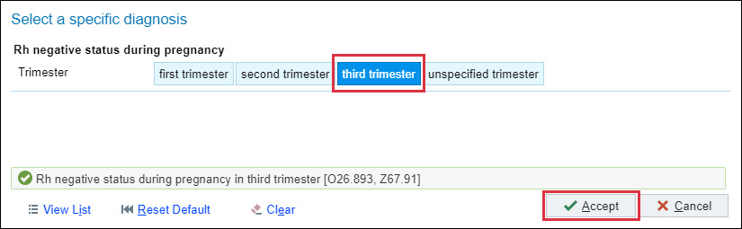
- Click Accept.

Orders Activity:

Now, you’ll place an order for her Rhogam

- Click the Preference List (next to the Add Order) 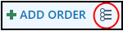 button.
- Click the arrow next to Clinic Administered Meds in the Navigator on the left side.
- Click Clinic Administered Meds, to view these types of meds.
- Select RHO(D) Immune Globulin medication to add it to the right column.

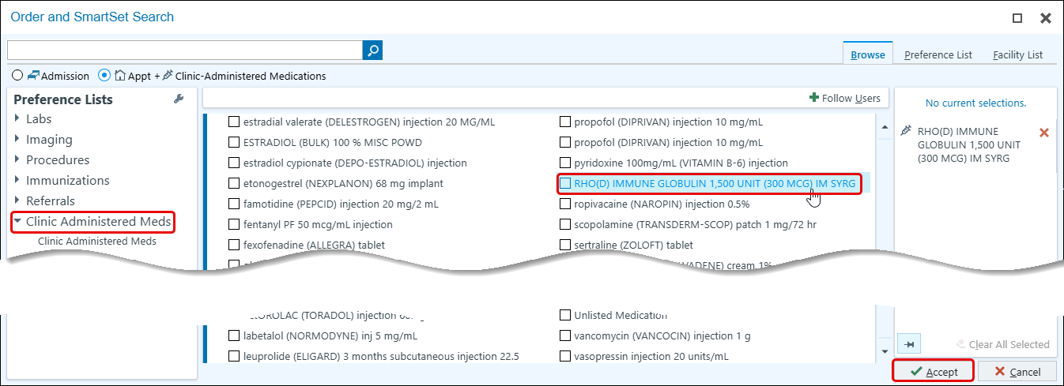

- Click Accept.
- Click on Dx Association.
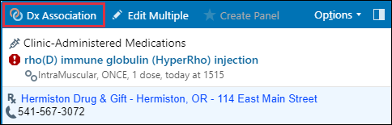

- Section Rh negative status during pregnancy in third trimester.

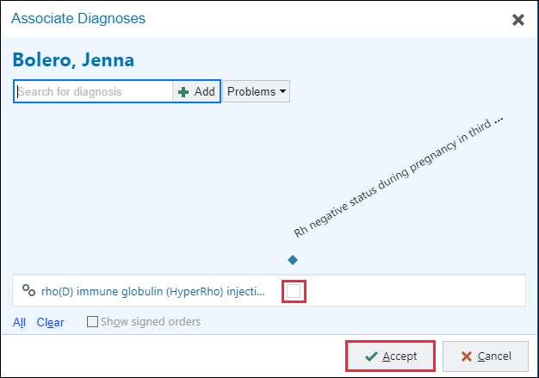

- Click Accept.
Notice the hard stop next to the RHO(D) Immune Globulin injection.
- Click the RHO(D) Immune Globulin to open the order.
- Satisfy the hard stops using the options available.
- Dose: 300 mcg

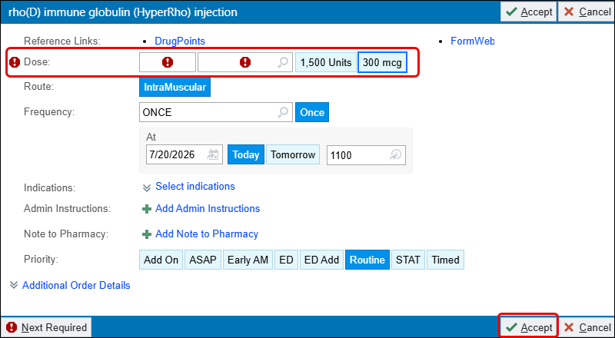

- Click Accept.
- Click the arrow pointing up next to the Sign Orders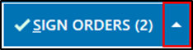 button.

The Provider’s window opens.
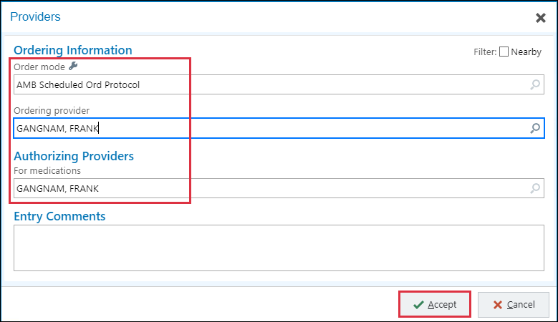
- Order Mode: AMB Scheduled Ord Protocol
- Ordering and Authorizing Provider, using the Frank provider from your login sheet.
- Click Accept.

You can begin documenting the injection into the note
Progress Note:
- In a blank spot in the Progress Note type .WHAHPIINJECTION
- Press F2 to work through the variables and wild cards available. Utilize the patient’s chart to fill in all the variables.
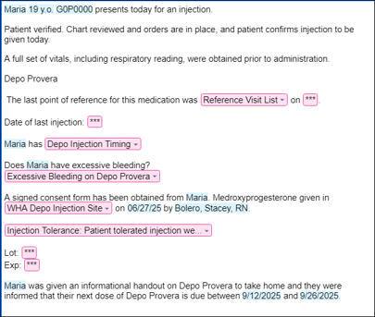

Now we will document the administration of the injection.
- Click button. (top right side)
- Hover over MAR.
- Click the pin .
- Select the Mar 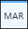 from your activity tabs.

MAR – Medication Administration Record activity: 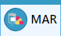

- Click within the blue block.
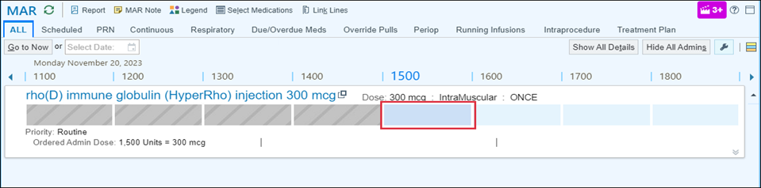
A Medication window opens.
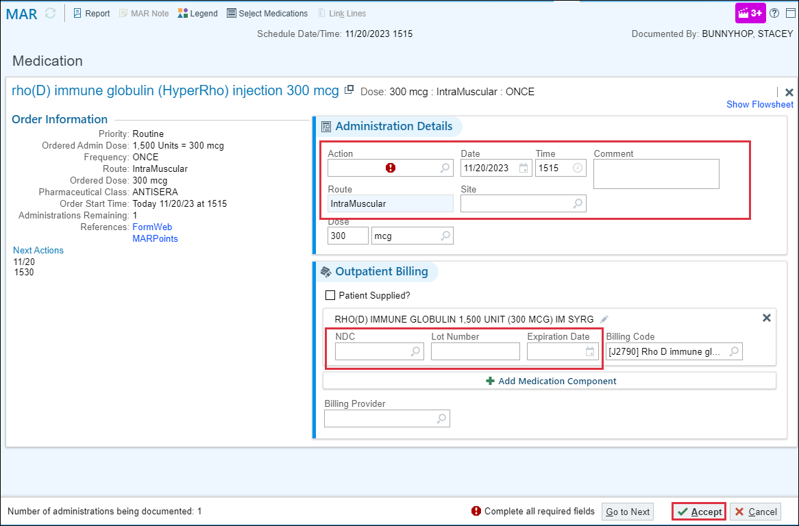
- Action: Given.
- Site: Ventrogluteal, Right
- NDC: click selection tool and choose the first option on the list.
- Lot #: 456612A
- Exp Date: y+2, then press Enter
- Billing Provider: your Frank
- Click Accept.

It is time for me to “Wrap Up” this visit.

This Visit:
I would like Rachel to come back in 1 week for her next OB visit.
- Click the 1-week button
- For: OB visit.

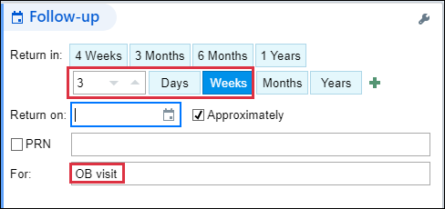

Preview the AVS before Printing.

- In the bottom task bar find the LOS field.
- Click the PR NURSE VISIT NO CHARGE button to select that level of service.
- Auth prov field: type in Frank (your provider)
- Click the Sign Encounter activity.
The Schedule will show her appointment as ‘Signed’

Module 6: IN BASKET Workflows

Exercise 1: Access the In Basket Activity

There are multiple ways of accessing In Basket messages.
1> In Basket workspace tab (Top of screen) 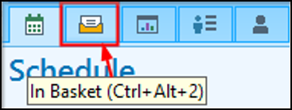
Access all messages and activities.
2> In Basket Card Viewer (Far right side of screen) 
Access Results, Rx Refills, and Patient Calls folders.
3> In Basket tool bar (top right of screen)
Reflection of current folders statuses in your In Basket.

The most efficient way to access any folder specifically is to click on the name of the folder in the In Basket toolbar.

- Click the Staff Message folder name on the In Basket toolbar at the bottom of the window.

Notice how that one click took us into the In Basket activity > Staff Message folder> Ready to review the messages.

Exercise 2: In Basket Functionality Demo
At this point, please do NOT click on anything so that I am able to show you this activities functionality.
Let’ browse the Home screen to get an overview of your work before diving in.
First notice there are new activity buttons specific for work in the In Basket.
- Home – The main screen to help you stay on top of tasks.
- Refresh – Manual refresh for the In Basket
- New Msg – To send a message to staff/providers.
- New Patient Msg – To send a message to patient using MyHealth.
- My Pools – To connect or disconnect from specific pools.
  - Pools are distribution lists in Epic; we will see more on how this work later.

Then moving over to the left side of the window….

- My Messages – 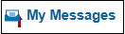
  - Current unresolved work; if there is no work to do, you won’t find the categorized folder.
- Folders – Will appear as you have tasks/work assigned to you.
  - Numbers indicate the number of new/total tasks in the folder.
At the bottom left of the activity, you see…
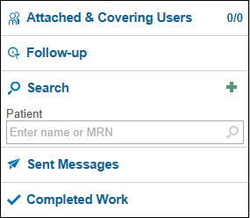
- Attached & Covering Users – Other users In Baskets you may be attached to and mainly used by providers.
- Follow-up – Use to apply flags, postpone or add comments to your messages.
- Search – To search for patients.
- Sent Messages – Messages you have sent during the day.
- Completed Work – Everything you have done/completed in the last 30 days.

While working the In Basket in-between patients, use the buttons on your home screen to quickly jump to New or High Priority messages.

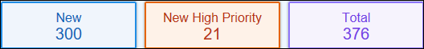

Hover to Refresh or Close the folder.

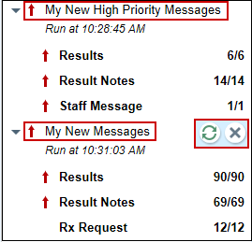

Since you are a part of Pool(s), you can monitor messages coming in and the total number messages using the Pools I’m Signed Into activity to keep work from piling up.

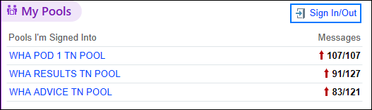

If you are looking for something specific, your Saved Searches can be seen in this activity so you can find the right messages when you need it.

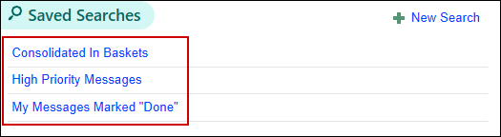

When looking for Sent Messages or Complete Work you can find those in the left Navigator.

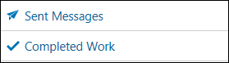

If you want to find a patient you don’t have open, use the Search in the left navigator.

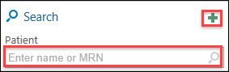
- Click the green plus for additional search options available.
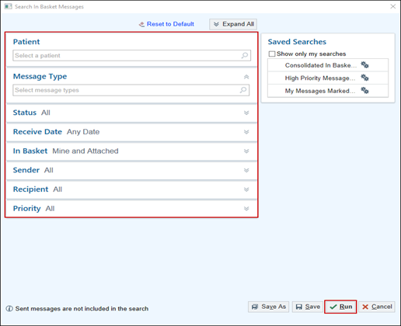
Now I will show you some of the basic functions of completing work in the In Basket.
Consistency is crucial for accomplishing tasks quickly therefore, no matter which folder you’re in, the buttons on the left of the tool bar stay put.

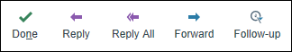
The Follow-up 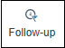 button has a few additional actions like Comments, Postpone and Flags to speed you up even more.

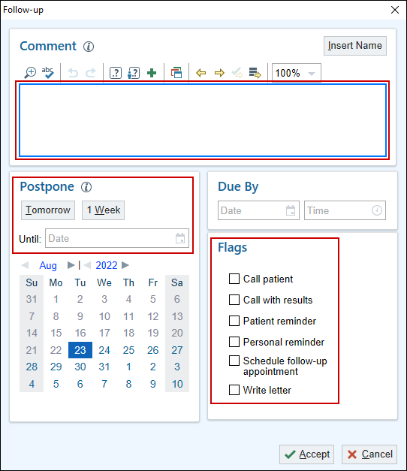

- Click the Insert Name button to add your name, date and time stamp to a comment.
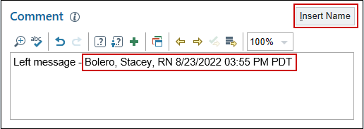
When in a folder, all messages will be listed in the first column or pane. I have a new Staff Message, because the folder & status of the message is New.

I can also see some specific information about this message, such as: Msg Date, Sender and Subject. We will talk about pool workflows here in another exercise.

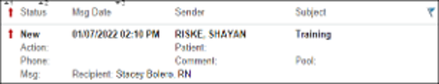

There is also a feature of Epic called “Auto Advance”. Once you have completed a message, Epic will automatically jump to the next message on the list and change its status from New to Read, saving you from having to click to select next messages.
This feature can be turned off by customizing this folder.
- Click the Wrench above the list of messages.
- Click the checked box next to Auto Advance.

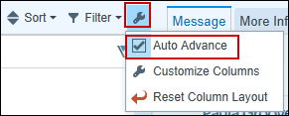

This customization must be done in every folder, but once it is done… You can “Set it and forget it”.

To the right of your screen, you see your Quick Filters as well as customizations and Help before you select on a message in the folder.

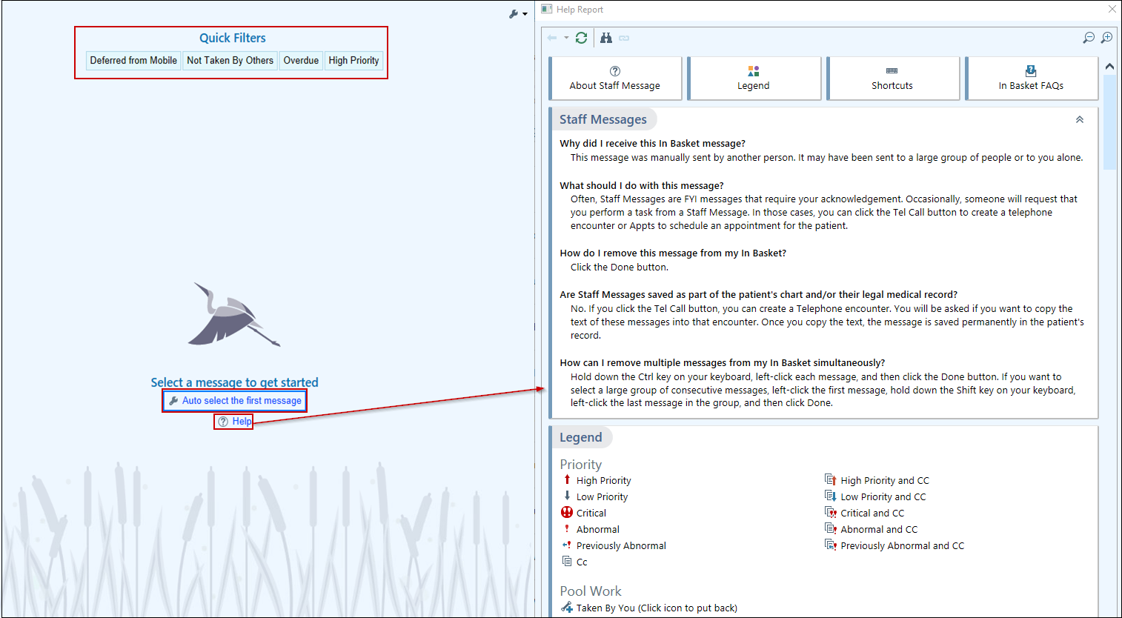
Now I will show you how to complete a message/ task in In Basket.
I will click the Staff Message about Training.

The message itself shows up in the right pane.
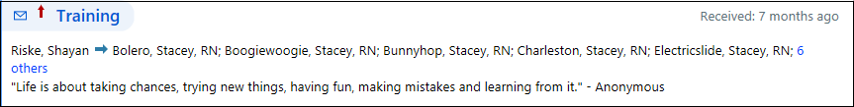
There are activity buttons specific to this type of message/ task to help you complete the work that has been assigned.
For this example, there is no more work that needs to be done, so I can “Done” it.
- Click the Done 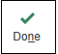 button.
The message status has changed to ‘Done’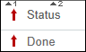.
- Click the Refresh 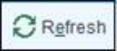 button.

Notice that the message disappears from the folder.

Exercise 4: Create Staff Message

Scenario: Paula needs serial HCG draws, and you want to make sure that the patient comes in for them. You will create a message and send it to the pool, for someone to call and speak with the patient.
- Click on New Msg
- In the To field: P WHA POD 1 TN POOL
- Subject: HCG Follow-up
- Patient: Type in your Grace patient
- Notes: Please make sure that patient is scheduled for her serial HCG. Thank you!
- Go to the Dates section, click to expand it.
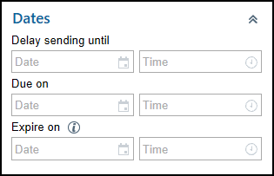

The Date field allows you to create the message now and have it sent in future.
- In the Delay sending until field: type T+3
- Click Send 